EE 275

Midterm Project: I

|  |  |  |  |
| --- | --- | --- | --- |
| Last Name :- | Nikola | Patel | Yadav |
| First Name :- | Pal | Dharm | Rushiraj |
| ID :- | 014512836 | 014532908 | 014513031 |
| Date:- | Arpil-16,2020 | | |

1. Introduction

The MIPS processor, designed in 1984 by researchers at Stanford University, is a RISC (Reduced Instruction Set Computer) processor. Compared with their CISC (Complex Instruction Set Computer) counterparts (such as the Intel Pentium processors), RISC processors typically support fewer and much simpler instructions. The premise is, however, that a RISC processor can be made much faster than a CISC processor because of its simpler design. These days, it is generally accepted that RISC processors are more efficient than CISC processors; and even the only popular CISC processor that is still around (Intel Pentium) internally translates the CISC instructions into RISC instructions before they are executed. RISC processors typically have a load-store architecture. This means there are two instructions for accessing memory: a load (l) instruction to load data from memory and a store (s) instruction to write data to memory. It also means that none of the other instructions can access memory directly. So, an instruction like "add this byte from memory to register 1" from a CISC instruction set would need two instructions in a load-store architecture: "load this byte from memory into register 2" and "add register 2 to register 1".

1. Basic Processor Architecture

The execution of an instruction in a processor can be split up into a number of stages. How many stages there are, and the purpose of each stage is different for each processor design. Examples includes 2 stages (Instruction Fetch / Instruction Execute) and 3 stages (Instruction Fetch, Instruction Decode, Instruction Execute). The MIPS processor has 5 stages:

IF:- The Instruction Fetch stage fetches the next instruction from memory using the address in the PC (Program Counter) register and stores this instruction in the IR (Instruction Register)

ID:- The Instruction Decode stage decodes the instruction in the IR, calculates the next PC, and reads any operands required from the register file.

EX:- The Execute stage "executes" the instruction. In fact, all ALU operations are done in this stage. (The ALU is the Arithmetic and Logic Unit and performs operations such as addition, subtraction, shifts left and right, etc.)

MA:- The Memory Access stage performs any memory access required by the current instruction, So, for loads, it would load an operand from memory. For stores, it would store an operand into memory. For all other instructions, it would do nothing.

WB:- For instructions that have a result (a destination register), the Write Back writes this result back to the register file. Note that this includes nearly all instructions, except nops (a nop, no-op or no-operation instruction simply does nothing) and s (stores).

1. Processor Modules
   1. Program Counter & Instruction Memory Block

|  |  |  |  |
| --- | --- | --- | --- |
| **Signals to**  **PC_IM Block** | **Input variable Name** | **No. of Bits** | **Explanation** |
| Inputs | jmp_loc | 16 | Address of jump location |
| pc_mux_sel | 1 | Selection bit for jmp_loc or pc_out |
| stall | 1 | Selection bit for address control mux |
| stall_pm | 1 | Selection bit for instruction control mux |
| reset | 1 | Reset signal for register, address and instruction |
| clk | 1 | Input clock signal |
| Outputs | ins | 32 | Instruction |
| current_address | 16 | Present address value for IM |

Table 2.1 Inputs & Outputs of the Block

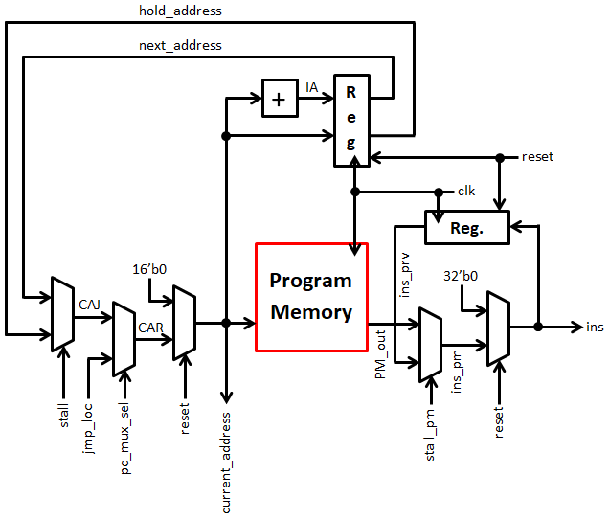

Figure 2.1 Program Counter & Instruction Memory

**Block Diagram Description:**

The objective of this block is to generate instructions for decode, execution and data memory blocks, and also take care of different controls. There are 3 different 2 x 1 multiplexer having selection line namely ‘stall’, ‘pc_mux_sel’ and ‘stall_pm’ respectively. ‘stall’ generated from ‘stall control’ block (i.e. one of the module of processor) which is used to select assign either hold_address or next_address as CAJ. ‘pc_mux_sel’ decides whether current address will pass to program memory or address provided by ‘jump control’ block. A mux with ‘stall_pm’ selection bit decides whether to pass actual instruction (PM_out) or pass previous instruction (ins_prv) to ‘ins_pm’. Another two multiplexers with ‘reset’ selection bit are used to reset ‘current_address’ and ‘ins’ values. Processor needs to generate new instruction at every positive edge of clock and ‘program counter’ will provide address of the new instruction. Program counter is combination of ‘increment’ (+) and ‘register’ block. ‘Increment’ block increments address and register will pass that value to ‘next_address’ on every positive edge of the clock and when there is reset it will clear the output of ‘register’. ‘reset’ is negative level triggered and clock synchronized. Another important block is program memory which has been designed using Xilinx IP core generator.

**Program Memory Specifications:**

* Single port ROM
* Data Read width is 32 bits
* Data Read depth is 65536 locations
* Inputs are 16-bit address, clock and reset
* Output is 32-bit instruction
  1. Dependency Check & Instruction Decode

|  |  |  |  |
| --- | --- | --- | --- |
| **Signals to**  **DC Block** | **Input variable Name** | **No. of Bits** | **Explanation** |
| Inputs | ins | 32 | Instruction from Program Memory |
| clk | 1 | Input clock signal |
| reset | 1 | Reset for registers/FFs |
| Outputs | imm | 16 | Immediate number |
| op_dec | 6 | Opcode |
| RW_dm | 5 | Write address |
| mux_sel_A | 2 | Selection bit for Mux A |
| mux_sel_B | 2 | Selection bit for Mux B |
| imm_sel | 1 | Immediate number select |
| mem_en_ex | 1 | Memory enable signal |
| mem_rw_ex | 1 | Memory read/write signal |
| mem_mux_sel_dm | 1 | Memory mux select bit |

Table 2.2 Inputs & Outputs of the Block

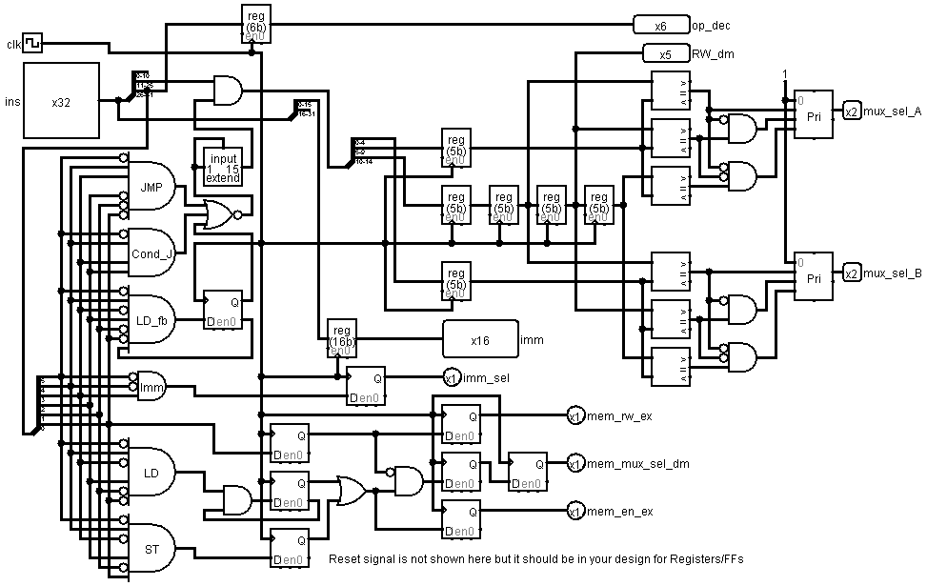

Figure 2.2 Dependency Check & Instruction Decode Block

**Block Diagram Description:**

Dependency check block handles data hazard in pipeline processor. It can check dependency of current instruction with previous three instructions and enables data forwarding in pipeline by generating ‘mux_sel_A’ and ‘mux_sel_B’ signals. This block also generates memory control and immediate control signals. All outputs of this block are generated at the positive edge of clock. Also, the block is responsible for decoding the opcode for execution stage as well as it will decode the addressed for register A, B and the address of the register where data is supposed to be stored.

* 1. Register Bank

|  |  |  |  |
| --- | --- | --- | --- |
| **Signals to**  **RB Block** | **Input variable Name** | **No. of Bits** | **Explanation** |
| Inputs | ans_ex | 16 | Answer from Execution block |
| ans_dm | 16 | Answer from Data Memory block |
| ans_wb | 16 | Answer from Writeback block |
| imm | 16 | Reset signal for register, address and instruction |
| RA | 5 | Register A read address |
| RB | 5 | Register B read address |
| RW_dm | 5 | Write address |
| mux_sel_A | 2 | Mux selection bit for A |
| mux_sel_B | 2 | Mux selection bit for BI |
| imm_sel | 1 | Immediate number select |
| clk | 1 | Input clock signal |
| Outputs | A | 16 | First operand for Execution block |
| B | 16 | Second operand for Execution block |

Table 2.3 Inputs & Outputs of the Block

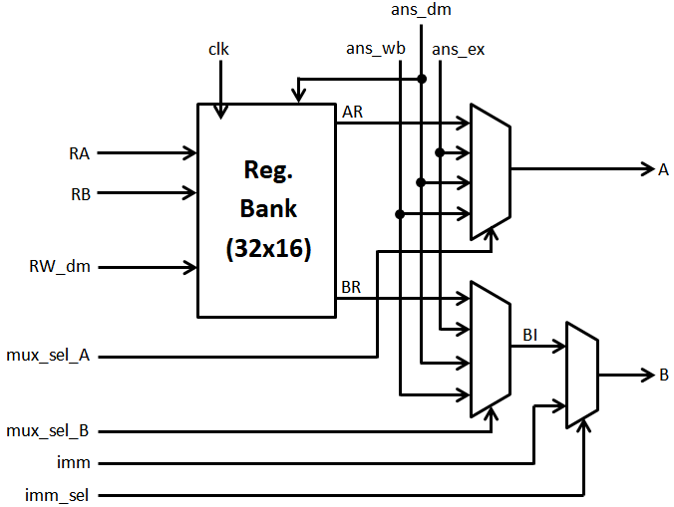

Figure 2.3 Register Bank

**Block Diagram Description:**

This block generates operands (A and B) for Execution block based on the instruction generated from Instruction Memory block. Input RA is used as first operand (A) address and input RB is used as second operand (B) address. If applied instruction is register type then both the operands fetched from register bank, else one of the operand (A) fetched from register bank and other operand (B) taken as immediate number (imm). This selection is controled by 2x1 Mux (with selection line imm_sel). Data forwarding operations performed by both 4x1 Mux based on the values applied to it’s selection line (mux_sel_A and mux_sel_B). Answer from Data Memory block (ans_dm) is written in register bank as per the address indicated by RW_dm.

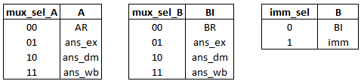

Figure 2.3 Mux Functionality

* 1. Execution Block

|  |  |  |  |
| --- | --- | --- | --- |
| **Signals to**  **Execution Block** | **Input variable Name** | **No. of Bits** | **Explanation** |
| Inputs | A | 16 | First operand for ALU operations |
| B | 16 | Second operand for ALU operations |
| data_in | 16 | Data from external input port |
| op_dec | 6 | Opcode |
| clk | 1 | Clock for execution block |
| reset | 1 | Reset signal to clear register of execution block |
| Outputs | ans_ex | 16 | Execution block output |
| DM_data | 16 | DM_data = B (Data for Data Memory block) |
| data_out | 16 | Data to external output port |
| flag_ex | 2 | Status bits :- flag_ex[1] = zero; flag_ex[0] = overflow; |

Table 2.4 Inputs & Outputs of the Block

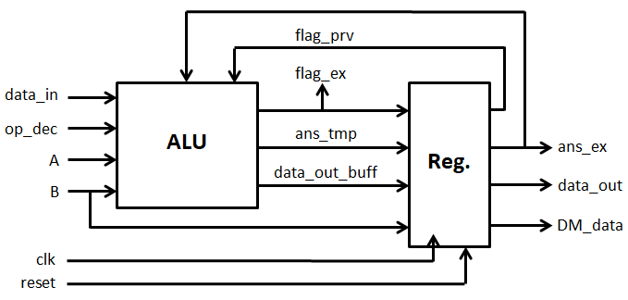

Figure 2.4 Execution Block

**Block Diagram Description:**

This block will take values A and B from register bank and perform operation based on the opcode. On the based of the operation performed the flags will be generate (zero flag & overflow flag). The result of the operation performed is then passed on to the next stage i.e. Data Memory Block. All the opcodes and respective operations with flag information and instruction set for the ALU is given below.

|  |  |  |  |  |
| --- | --- | --- | --- | --- |
| **Sr. No.** | **Instruction** | **Opcode** | **Operation in Execution Block** | **Flags Affected** |
| 1 | ADD | 000000 | ans_ex = A+B | Overflow, Zero |
| 2 | SUB | 000001 | ans_ex = A-B | Overflow, Zero |
| 3 | MOV | 000010 | ans_ex = B | Zero (Reset Overflow flag) |
| 4 | MUL | 000011 | ans_ex = A*B | Zero (Reset Overflow flag) |
| 5 | AND | 000100 | ans_ex = A&B | Zero (Reset Overflow flag) |
| 6 | OR | 000101 | ans_ex = A|B | Zero (Reset Overflow flag) |
| 7 | XOR | 000110 | ans_ex = A^B | Zero (Reset Overflow flag) |
| 8 | NOT | 000111 | ans_ex = ~B | Zero (Reset Overflow flag) |
| 9 | ADI | 001000 | ans_ex = A+B | Overflow, Zero |
| 10 | SBI | 001001 | ans_ex = A-B | Overflow, Zero |
| 11 | MVI | 001010 | ans_ex = B | Zero (Reset Overflow flag) |
| 12 | ANI | 001100 | ans_ex = A&B | Zero (Reset Overflow flag) |
| 13 | ORI | 001101 | ans_ex = A|B | Zero (Reset Overflow flag) |
| 14 | XRI | 001110 | ans_ex = A^B | Zero (Reset Overflow flag) |
| 15 | NTI | 001111 | ans_ex = ~B | Zero (Reset Overflow flag) |
| 16 | RET | 010000 | Hold previous ‘ans_ex’ | Reset all flags |
| 17 | HLT | 010001 | Hold previous ‘ans_ex’ | Reset all flags |
| 18 | LD | 010100 | ans_ex = A | Reset all flags |
| 19 | ST | 010101 | ans_ex = A | Reset all flags |
| 20 | IN | 010110 | ans_ex=data_in | Zero (Reset Overflow flag) |
| 21 | OUT | 010111 | Hold previous ‘ans_ex’  data_out = A | Reset all flags |
| 22 | JMP | 011000 | Hold previous ‘ans_ex’ | Reset all flags |
| 23 | LS | 011001 | ans_ex = A<<B | Zero (Reset Overflow flag) |
| 24 | RS | 011010 | ans_ex = A>>B | Zero (Reset Overflow flag) |
| 25 | RSA | 011011 | ans_ex = A>>>B | Zero (Reset Overflow flag) |
| 26 | JV | 011100 | Hold previous ‘ans_ex’ | Previous State |
| 27 | JNV | 011101 | Hold previous ‘ans_ex’ | Previous State |
| 28 | JZ | 011110 | Hold previous ‘ans_ex’ | Previous State |
| 29 | JNZ | 011111 | Hold previous ‘ans_ex’ | Previous State |

Table 2.4.0 Opcodes & Operations

|  |  |
| --- | --- |
| MOV | Move data from register to register |
| MVI | Move immediate data to register |
| LD | Move data from data memory to register |
| ST | Move data from register to data memory |
| IN | Move data from input to register |
| OUT | Move data from register to output |

Table 2.4.1 Data Transfer Instructions

|  |  |
| --- | --- |
| ADD | Add data of two registers |
| SUB | Subtract data of two registers |
| MUL | Multiply data of two registers |
| AND | Perform AND operation on the data of two registers |
| OR | Perform OR operation on the data of two registers |
| XOR | Perform XOR operation on the data of two registers |
| NOT | Perform NOT operation on the data of two registers |
| ADI | Add immediate number with register data |
| SBI | Subtract immediate number from register data |
| ANI | Perform AND operation between immediate number with the data register |
| ORI | Perform OR operation between immediate number with the data register |
| XRI | Perform XOR operation between immediate number with the data register |
| NTI | Perform NOT operation between immediate number with the data register |
| LS | Perform left shift operation on register data |
| RS | Perform right shift operation on register data |
| RSA | Perform arithmetic right shift operation on register data |

Table 2.4.2 Arithmetic & Logical Instructions

|  |  |
| --- | --- |
| RET | Return to program memory address after completion of interrupt sub-routine |
| HLT | Stop the execution of program |
| JMP | Unconditional jump to given program memory address location |
| JV | Jump to given program memory address location if overflow flag is 1 |
| JNV | Jump to given program memory address location if overflow flag is 0 |
| JZ | Jump to given program memory address location if zero flag is 1 |
| JNZ | Jump to given program memory address location if zero flag is 0 |

Table 2.4.3 Conditional Instructions

* 1. Jump Control

|  |  |  |  |
| --- | --- | --- | --- |
| **Signals to**  **JC Block** | **Input variable Name** | **No. of Bits** | **Explanation** |
| Inputs | jmp_address_pm | 16 | Jump address from instruction (ins) |
| current_address | 16 | Address of current instruction |
| op | 6 | Opcode |
| flag_ex | 2 | Flag from execution block |
| interrupt | 1 | External interrupt signal (Non maskable) |
| clk | 1 | Input clock signal |
| reset | 1 | Reset for registers/FFs |
| Outputs | jmp_loc | 16 | Jump address for PC_IM block |
| pc_mux_sel | 1 | Mux selection bit for PC_IM block |

Table 2.5 Inputs & Outputs of the Block

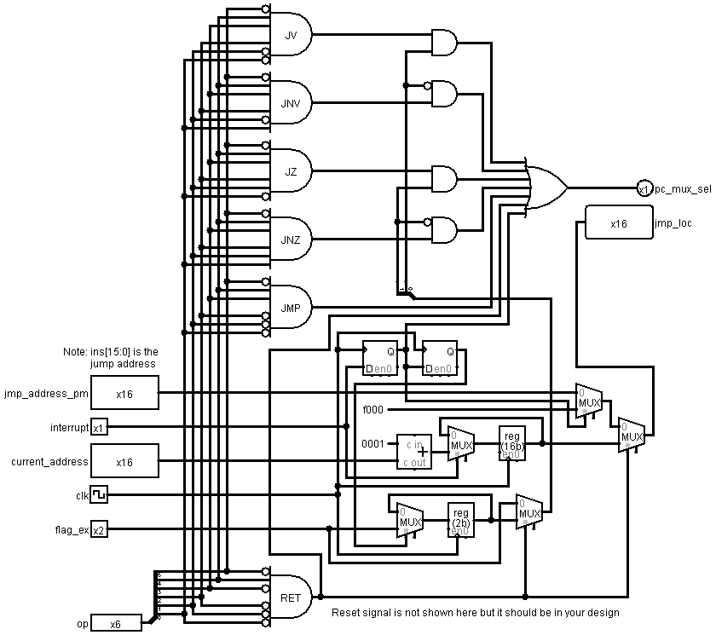

Figure 2.5 Jump Control Block

**Block Diagram Description:**

Jump control block generates jump location address (jmp_loc) and mux control signal (pc_mux_sel) for program memory block, based on jump conditions and value of interrupt. For conditional jumps (JC, JNC, JZ and JNZ), if condition is true then ‘pc_mux_sel’ value will be ‘1’, else we check for unconditional jump (JMP), interrupt and return (RET) instructions, if any of these instruction/signal is true then also ‘pc_mux_sel’ value will be ‘1’, for other cases ‘pc_mux_sel’ value will be ‘0’. When interrupt signal value is ‘1’, we stores ‘current_address’ and ‘flag_ex’ in the system and program will jump to interrupt subroutine location (16’hF000). When interrupt subroutine is over then we provide RET instruction to continue our main program, for that we need to reproduce ‘current_address’ and ‘flag_ex’ which was previously stored in system.

* 1. Stall Control

|  |  |  |  |
| --- | --- | --- | --- |
| **Signals to**  **SC Block** | **Input variable Name** | **No. of Bits** | **Explanation** |
| Inputs | op | 6 | Opcode |
| clk | 1 | Input clock signal |
| reset | 1 | Reset for FFs |
| Outputs | stall | 1 | Stall signal for PC_IM block |
| stall_pm | 1 | Delayed stall signal for PC_IM block |

Table 2.6 Inputs & Outputs of the Block

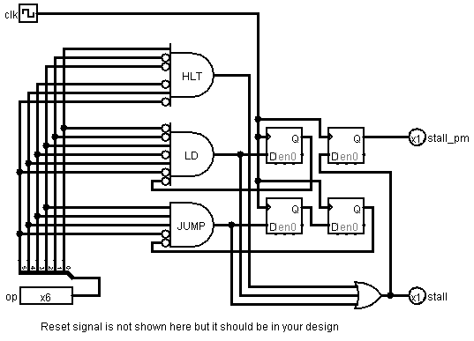

Figure 2.6 Stall Control Block

**Block Diagram Description:**

Some instructions like ‘Load’ and ‘Conditional Jump’ are creating control hazard in pipeline processor. To overcome this problem, we need to stall pipeline for one or two clock cycles. Stall Control block decides when to stall a pipeline. Also, this block will stall pipeline forever when ‘HLT’ instruction will execute.

* 1. Data Memory

|  |  |  |  |
| --- | --- | --- | --- |
| **Signals to**  **DM Block** | **Input variable Name** | **No. of Bits** | **Explanation** |
| Inputs | ans_ex | 16 | Answer from Execution block (used as address) |
| DM_data | 16 | Input data for Data Memory |
| mem_rw_ex | 1 | Memory read/write signal |
| mem_en_ex | 1 | Memory enable signal |
| mem_mux_sel_dm | 1 | Mux selection bit for ans_dm |
| reset | 1 | Reset signal for register |
| clk | 1 | Input clock signal |
| Outputs | ans_dm | 16 | First operand for Execution block |

Table 2.7 Inputs & Outputs of the Block

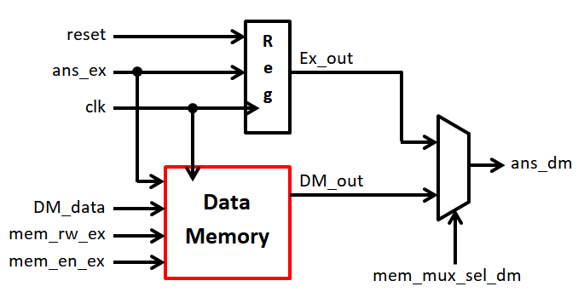

Figure 2.7 Data Memory Block

**Block Diagram Description:**

Data Memory is designed using IP core. It’s a 65536x16 RAM with R/W and enable signal. Data read or write in Data Memory is possible only if ‘mem_en_ex’ signal is 1. If ‘mem_rw_ex’ is 0 data read operation will perform else data write. Data written in the Data Memory should be provided to ‘DM_data’; and ‘ans_ex’ is used as an address. 2x1 Mux is used to select between execution block answer (Ex_out) or Data Memory’s output (DM_out). When ‘mem_mux_sel_dm’ is 1, it will select ‘DM_out’ as an ‘ans_dm’ else it will select ‘Ex_out’ as an ‘ans_dm’.

* 1. Write Back

|  |  |  |  |
| --- | --- | --- | --- |
| **Signals to**  **WB Block** | **Input variable Name** | **No. of Bits** | **Explanation** |
| Inputs | ans_dm | 16 | Output of Data Memory block |
| clk | 1 | Input clock signal |
| reset | 1 | Reset signal for register |
| Output | ans_wb | 16 | Output of Write Back block |

Table 2.8 Inputs & Outputs of the Block

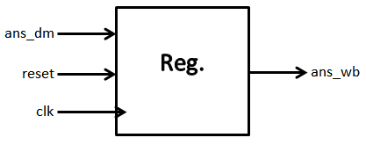

Figure 2.8 Write Back Stage

**Block Diagram Description:**

Write Back block is used to delay ‘ans_dm’ for one clock cycle. This block helps to resolve read after write hazard in the IDOF (Instruction Decode and Operand Fetch) stage.

1. Executed Instruction Set

|  |  |  |  |  |  |  |
| --- | --- | --- | --- | --- | --- | --- |
| **Ins No.** | **Operation** | **Load / Store Address** | **Address of operand A** | **Address of operand B** | **Immediate Value / Jump address** | **Operation Description** |
| 1 | MOVI | $0 | $0 | $0 | 0 | Move Immediate 0 to $0 |
| 2 | MOVI | $3 | $0 | $0 | 3 | Move Immediate 3 to $3 |
| 3 | MOVI | $5 | $0 | $0 | 5 | Move Immediate 5 to $5 |
| 4 | MOVI | $7 | $0 | $0 | 9 | Move Immediate 9 to $7 |
| 5 | ADD | $1 | $0 | $0 | 0 | Add $0 + $0 -> $1 |
| 6 | LD | $2 | $3 | $0 | 0 | Load from $3 -> $2 |
| 7 | LD | $4 | $5 | $0 | 0 | Load from $5 -> $2 |
| 8 | MUL | $2 | $2 | $4 | 0 | Multiply $2 * $4 -> $4 |
| 9 | ADD | $1 | $1 | $2 | 0 | Add $1 + $2 -> $1 |
| 10 | ADDI | $3 | $3 | $0 | 4 | Add Immediate $3 + 4 -> $3 |
| 11 | ADDI | $5 | $5 | $0 | 4 | Add Immediate $5 + 4 -> $5 |
| 12 | SUBI | $7 | $7 | $0 | 1 | Sub Immediate $7 – 1 -> $7 |
| 13 | JNZ | $0 | $0 | $0 | 5 | Jump to Ins 6. if $7 != 0(loop) |
| 14 | OUT | $0 | $1 | $0 | 0 | Output to external world |
| 15 | ST | $0 | $1 | $0 | 0 | Store $1 -> $0 |
| 16 | HLT | $0 | $0 | $0 | 0 | Halt |

Table 3.1 Instruction Set Architecture for the given Task

The dot product of the two student ID’s having 9 is performed using the above instruction set architecture. For that purpose, the program memory has been uploaded with the instruction set and the data memory has been loaded with the two student ID’s. Example using the ID’s is shown below

Student ID-1 :- 014512836

Student ID-2 :- 014532908

The dot product of the above two ID’s is shown below

(0 x 0)+(1 x 1)+(4 x 4)+(5 x 5)+(1 x 3)+(2 x 2)+(8 x 9)+(3 x 0)+(6 x 8) = 169

The instructions 5 to 6 are used to initialize the registers in the reg bank so that they can be used for the main instruction set which start from Ins 6. And ends at Ins 16. The Program Memory and The data memory have been initialized by uploading a **.txt** file also called as **COE** file.

1. Behavioral Simulation

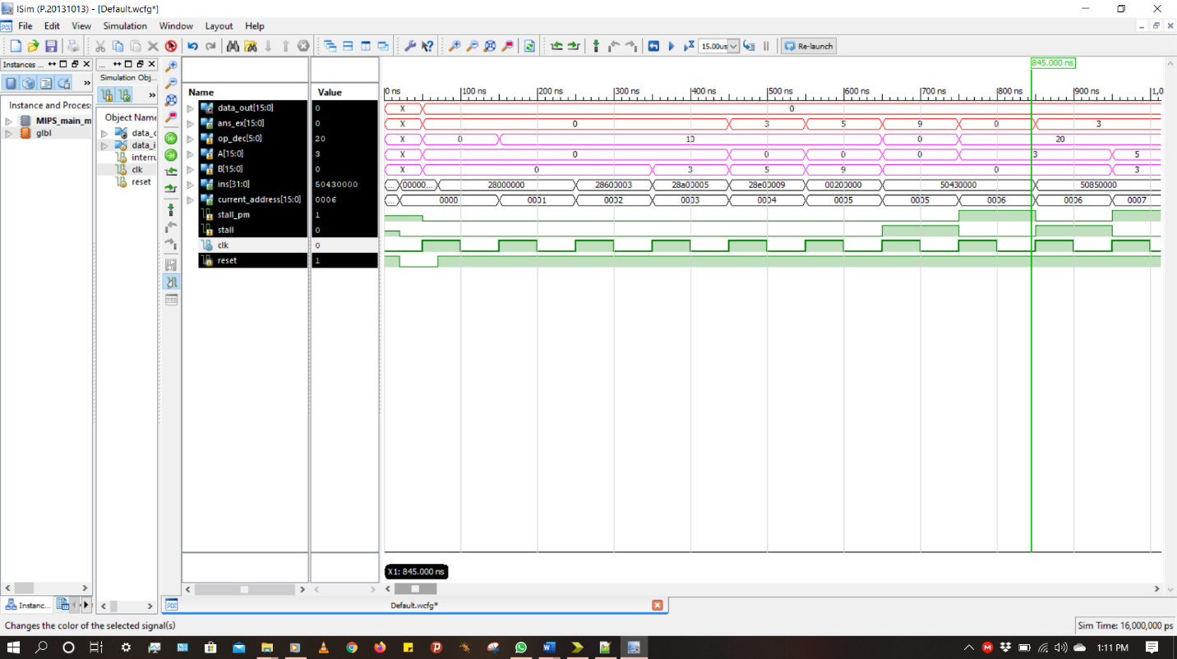

Figure 4.1 Simulation Results

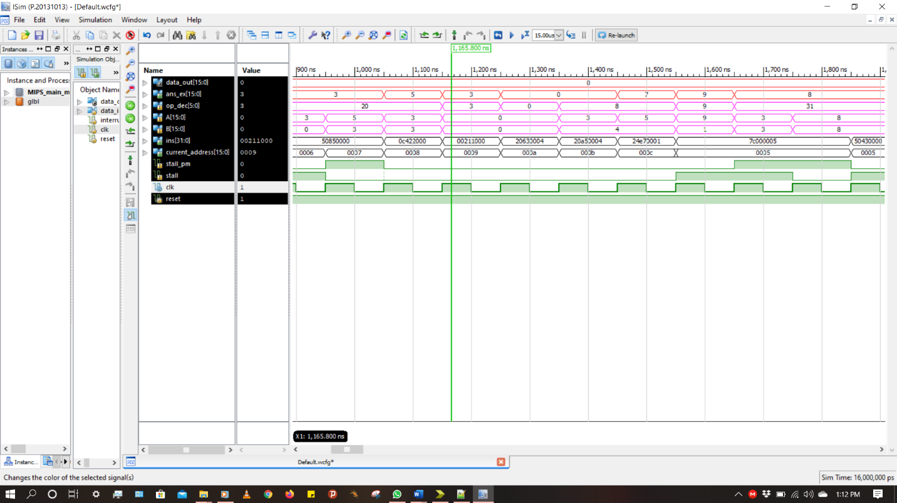

Figure 4.2 Simulation Results

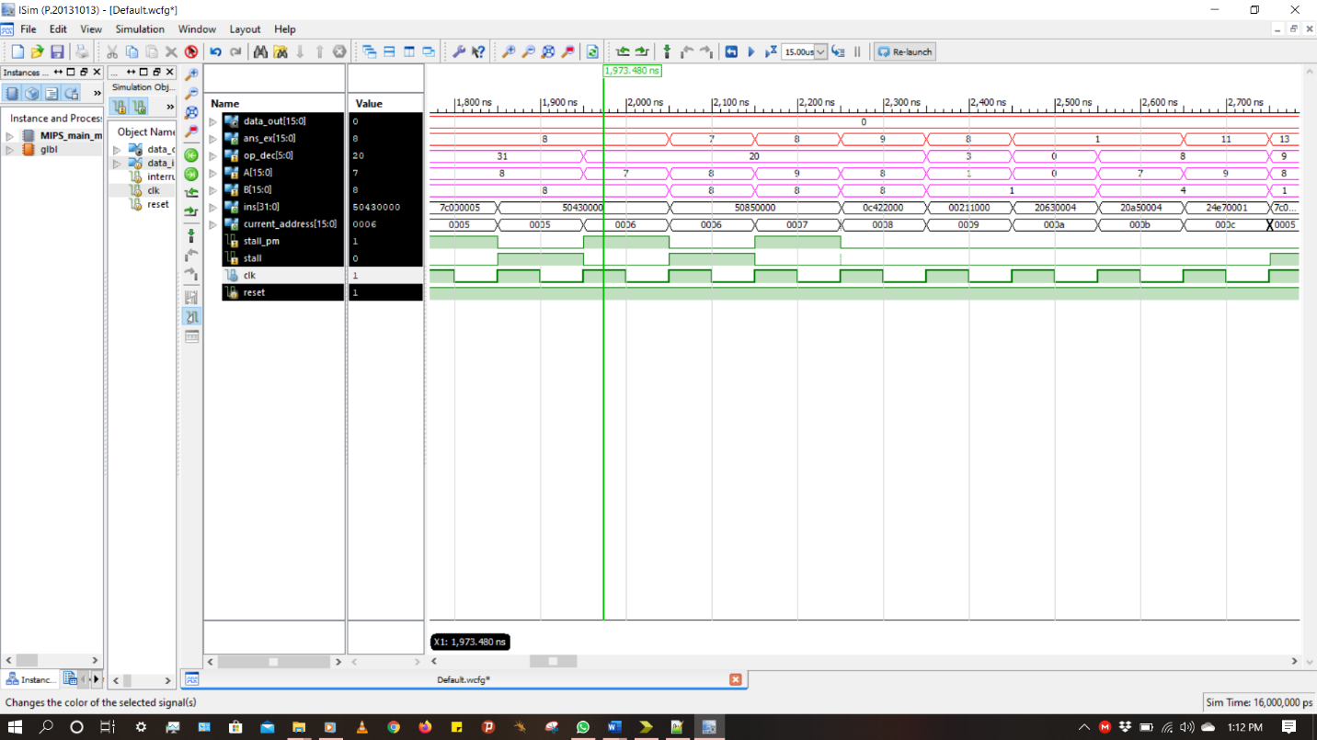

Figure 4.3 Simulation Results

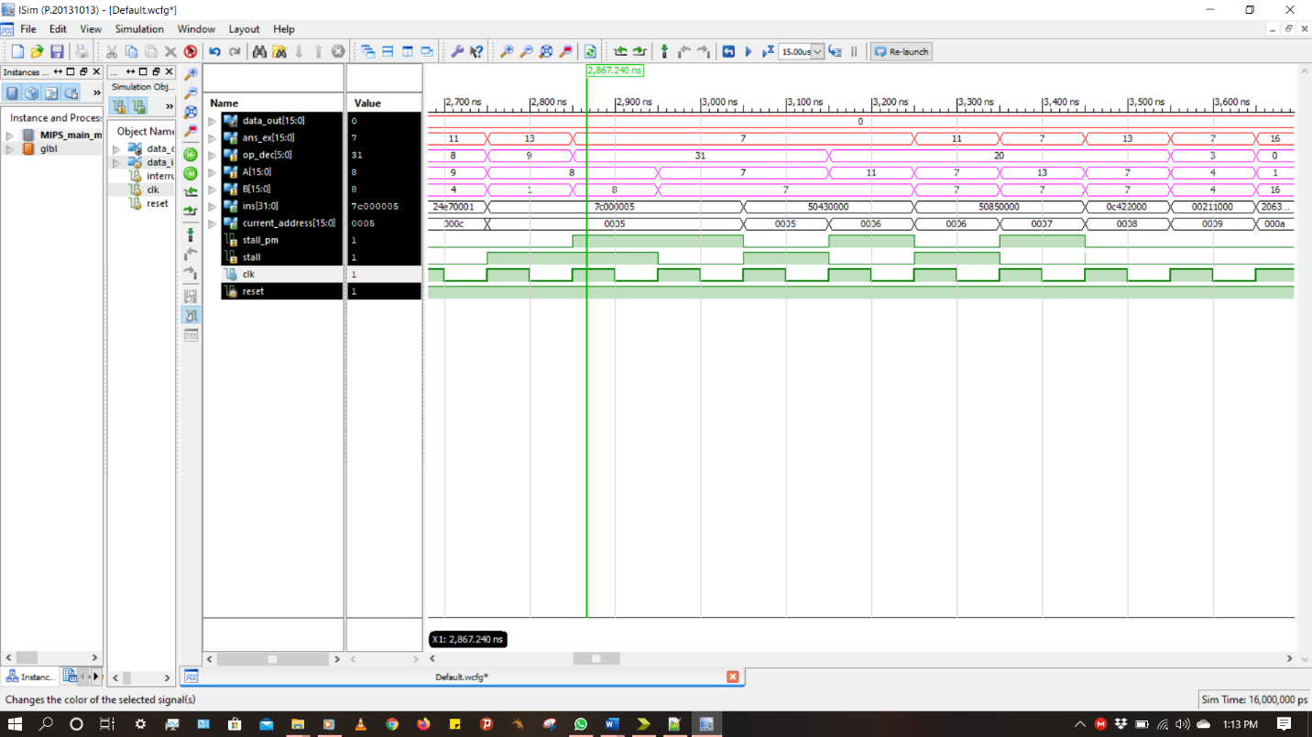

Figure 4.4 Simulation Results

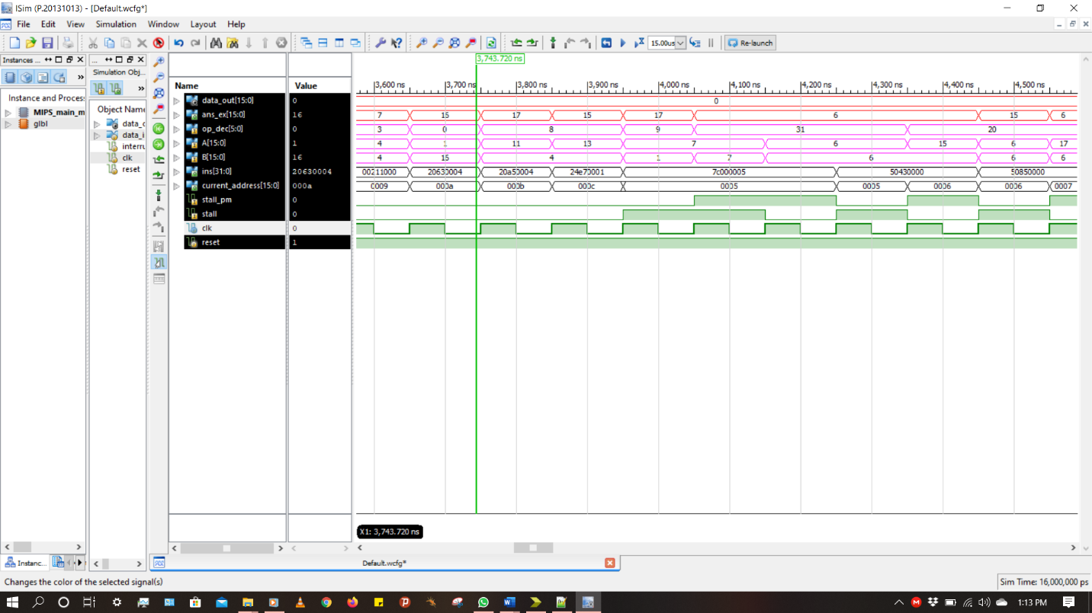

Figure 4.5 Simulation Results

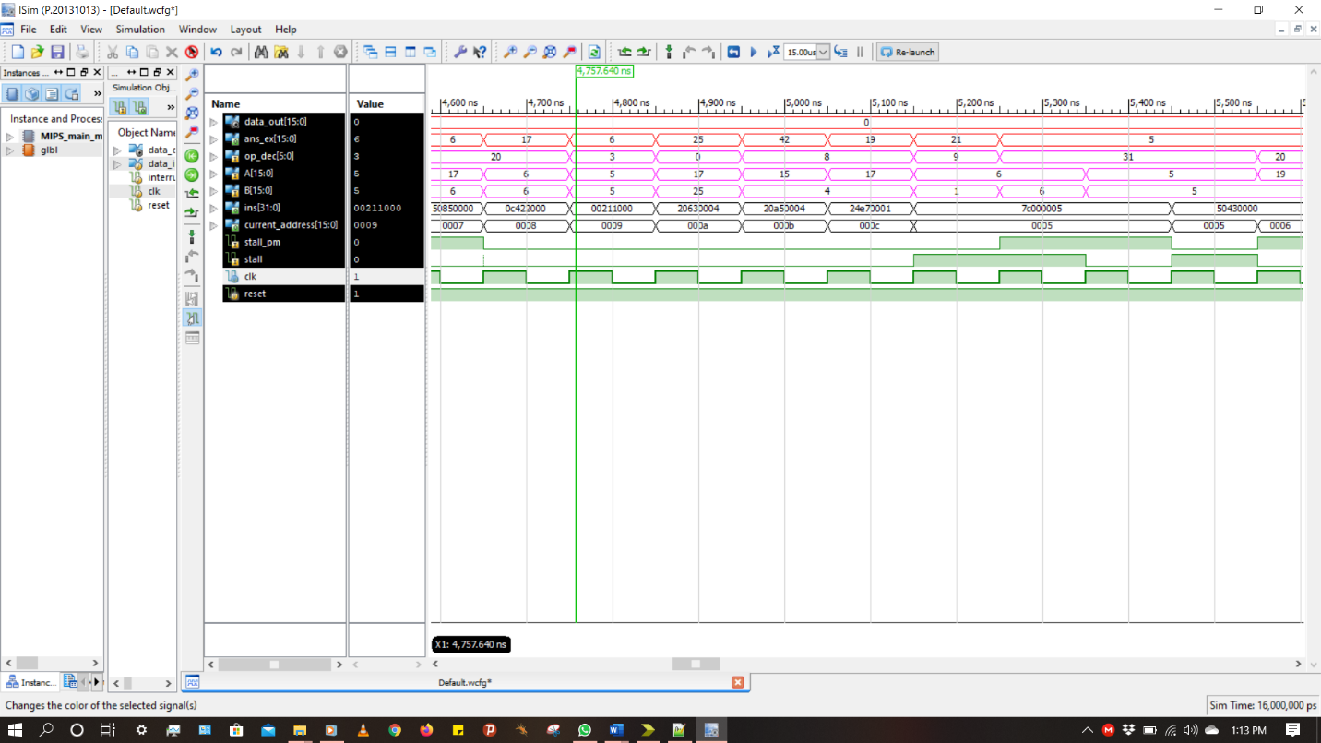

Figure 4.6 Simulation Results

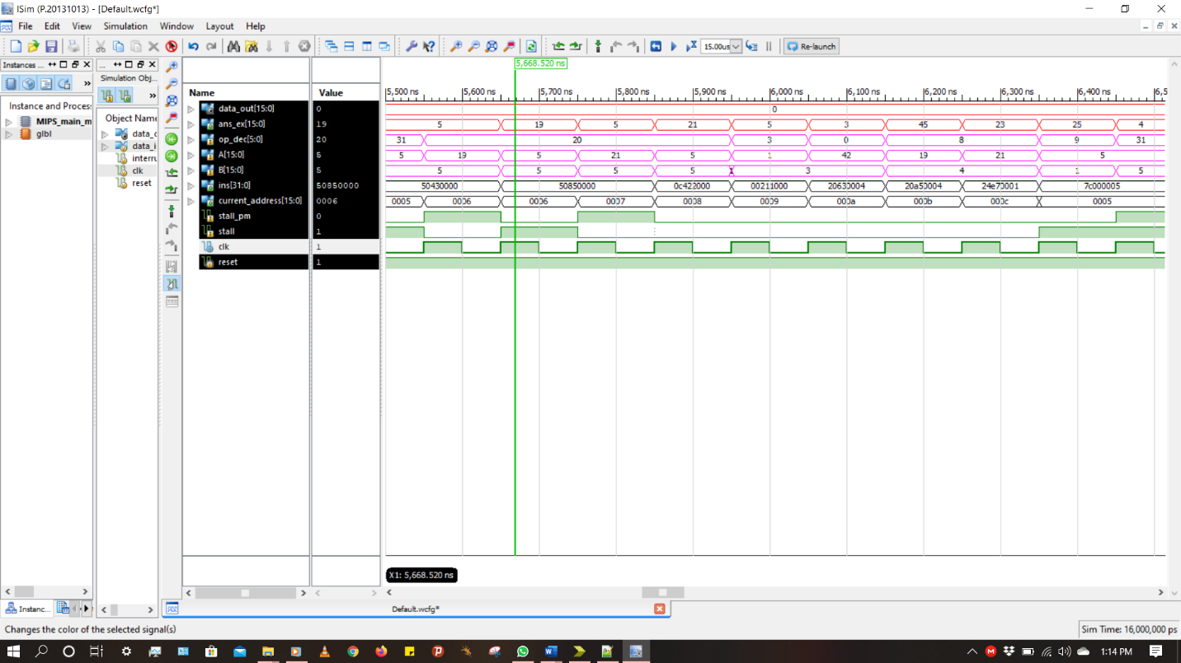

Figure 4.7 Simulation Results

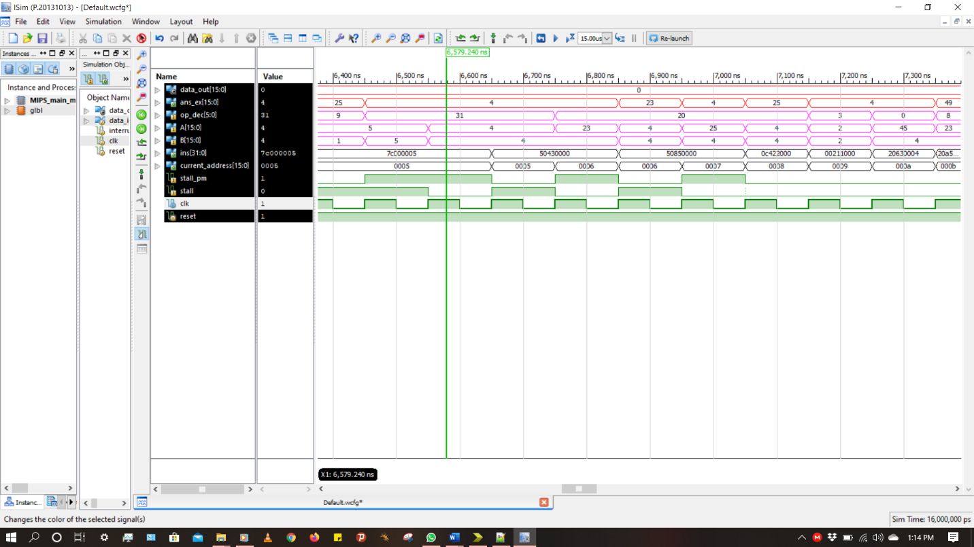

Figure 4.8 Simulation Results

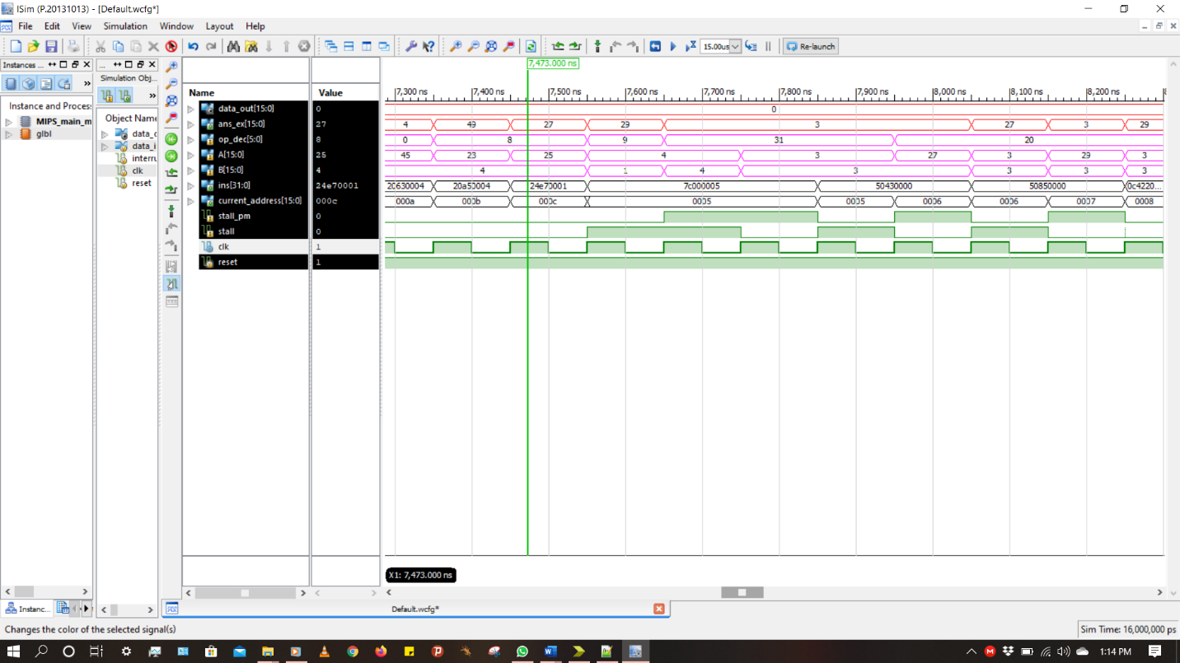

Figure 4.9 Simulation Results

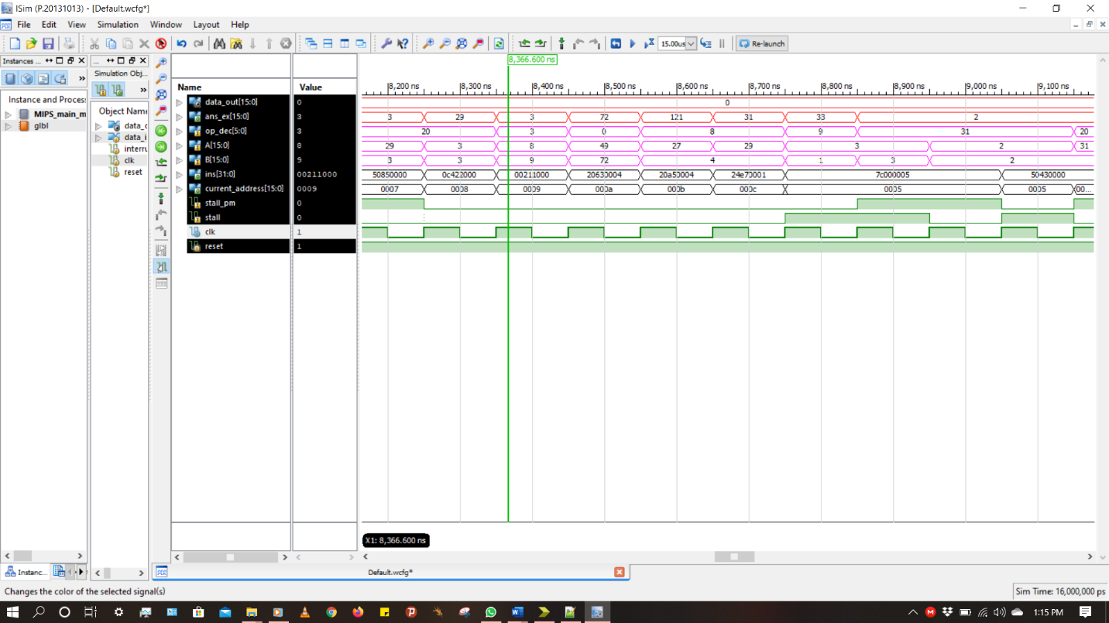

Figure 4.10 Simulation Results

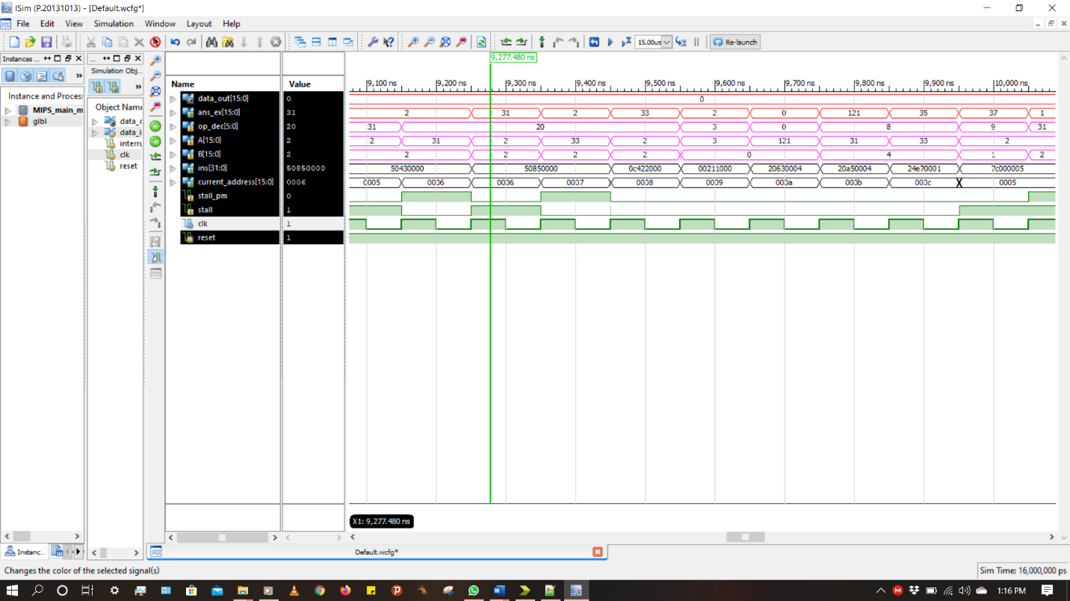

Figure 4.11 Simulation Results

­­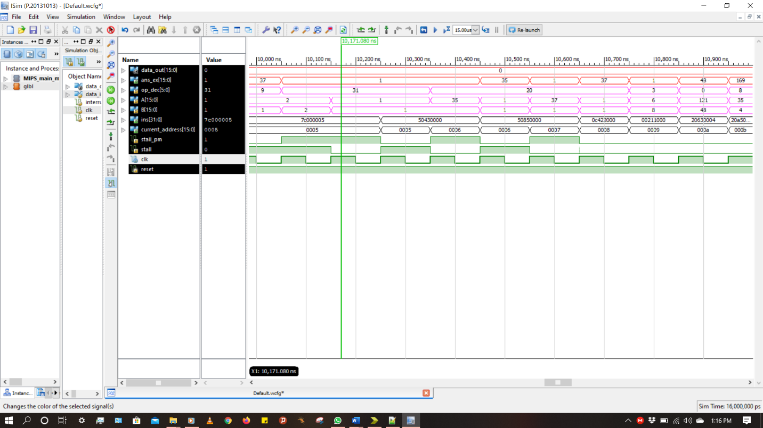

Figure 4.12 Simulation Results

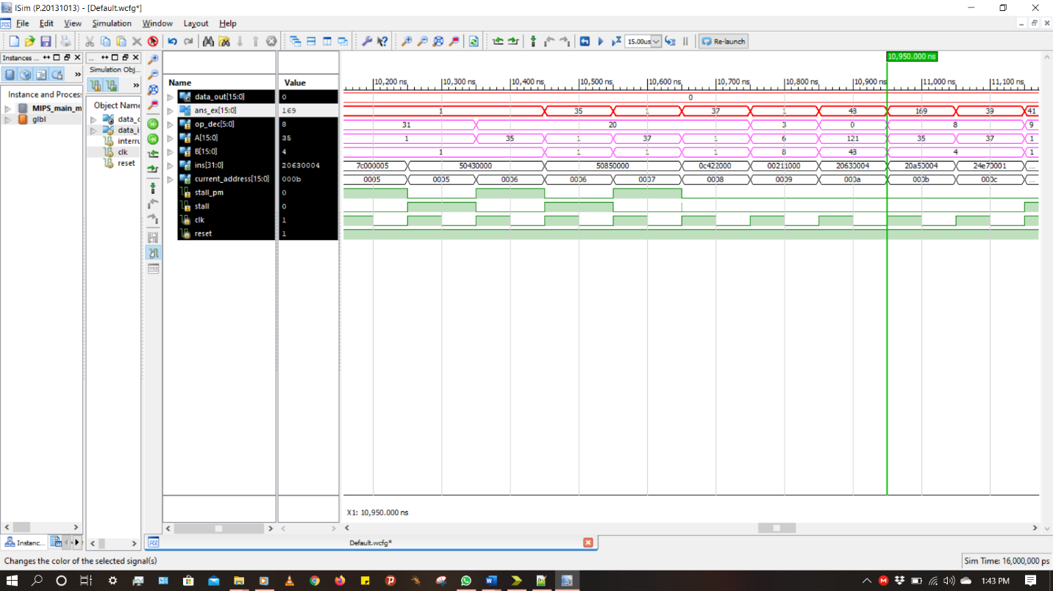

Figure 4.13 Simulation Results

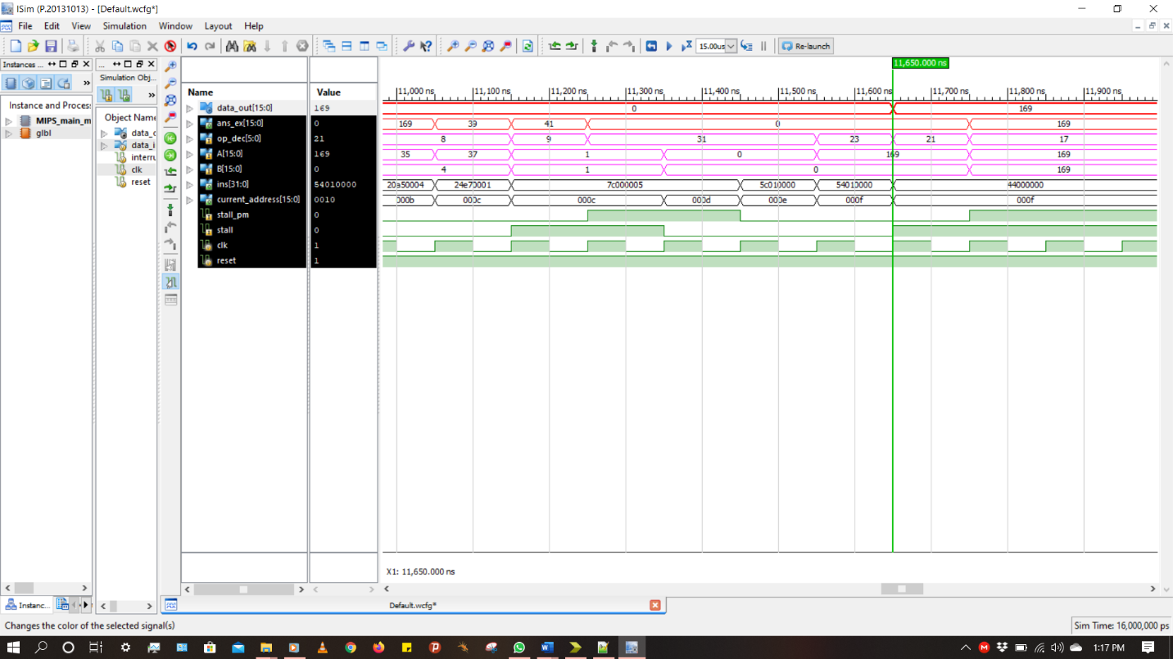

Figure 4.14 Simulation Results

The Figures 4.1 to 4.13 show the complete simulation of the executed instruction mentioned in the above section III for two student ID’s (014512836 & 014532908). As shown in the Figure 4.13 the **ans_ex = 169 @ 10950ns i.e. 10.95us** after that the dot product is pushed out to the external world using OUT operation and that change takes place **data_out = 169 @11650ns i.e. 11.65us** as shown in Figure 4.14. In all the above figures the **data_out** is the output of 16-bits from the processor to the external world. Variable **op_dec** is the operational code of 6-bits for ALU. Variable **A** and **B** are the two operands of 16-bits for the ALU. Variable **ins** is 32-bits instruction shown in hex format. Variable **current_address** is the 16-bits address value for the program memory to fetch the instructions. Variables **Stall** and **Stall_pm** are the 1-bit signals generated by stall control block to stall the current_address and ins to avoid control hazards.

1. Synthesis Results

The 5-stage 32-bits MIPS pipelined processor has been coded in Verilog-HDL using Xilinx-ISE 14.7. The target device is nexys4-DDR Artix7 FPGA which has clock frequency of 100Mhz. Show below is the resource utilization done after performing synthesis on the targeted device.

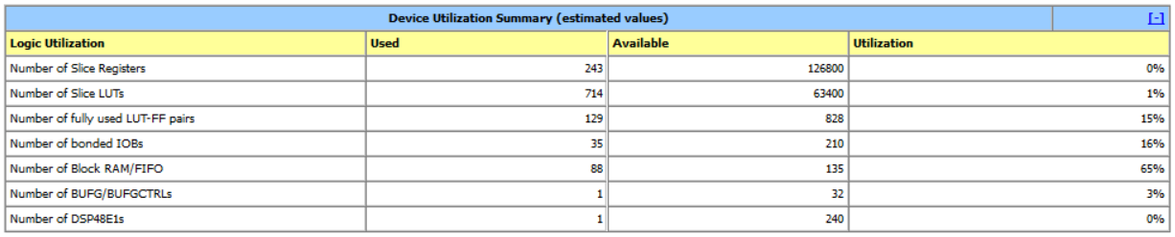

Figure 5.1 Resource Utilization Summary

1. Block Diagram of Processor

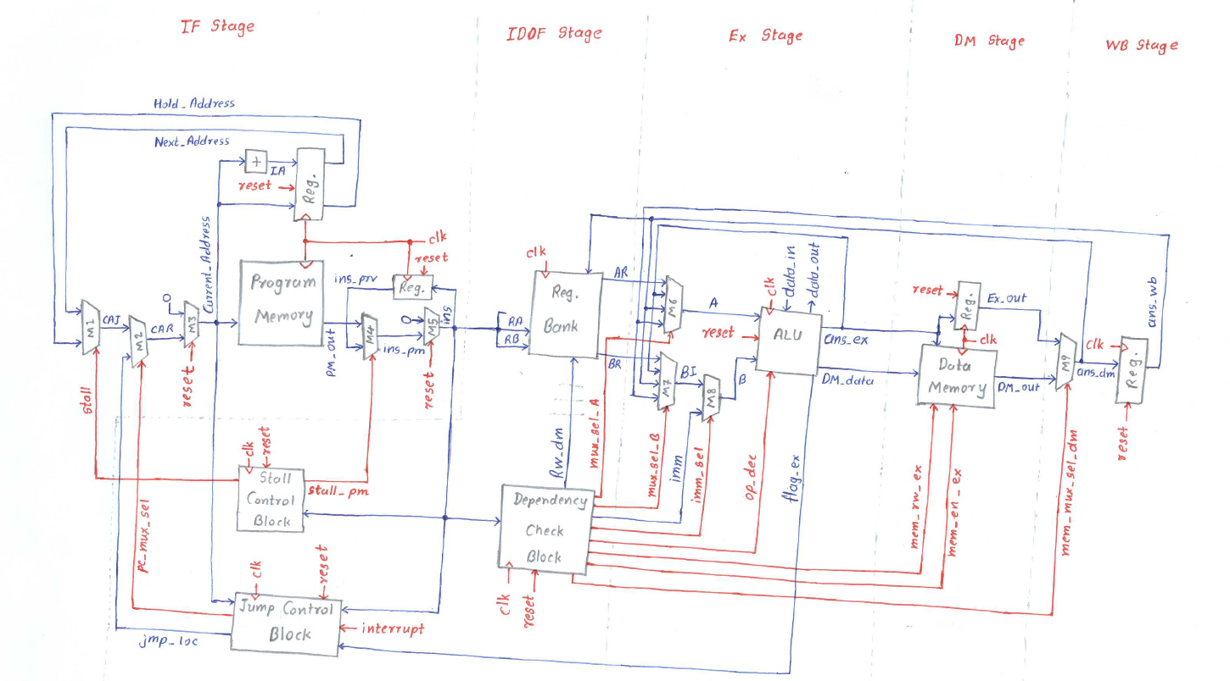

Figure 6.2 5-stage pipeline processor block diagram

1. RTL Schematic of MIPS processor

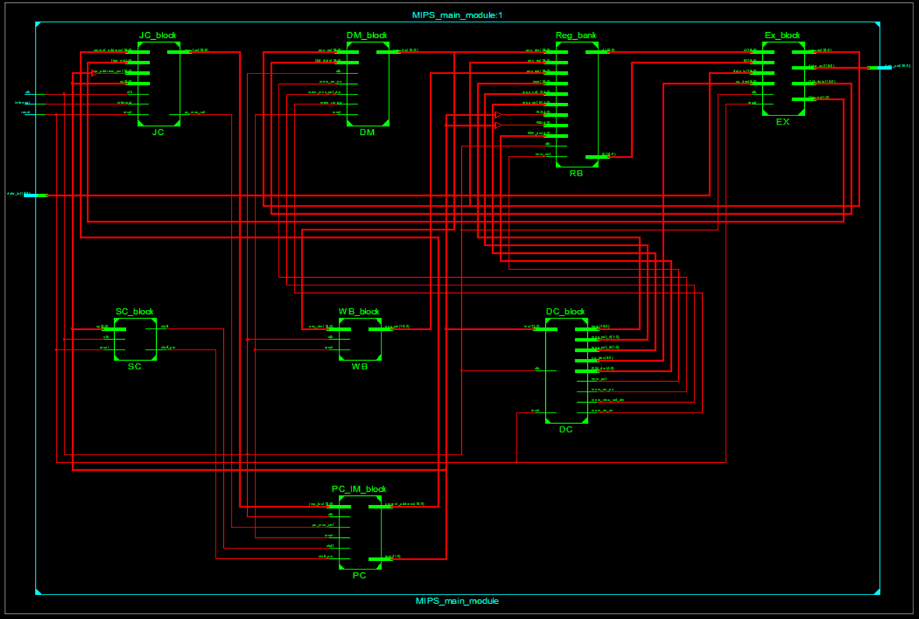

Figure 7.1 RTL schematic generate by Xilinx -ISE 14.7

1. Verilog-Codes & Test Bench

Each and Every Module of the processor has been verified individually using individual testbench. All the Verilog modules of the processor are in the folder “**1. 32-bits MIPS Processor Verilog Codes**”. All the test benches are in the folder “2. Test Bench”. The instruction set used in the program memory IP core is the folder “**3. Program Memory File**”. The data file used to fill data memory with student ID’s is in the folder “**4. Data Memory File**”.

1. Important Note

We are not following the coding guidelines given by the Professor about adding the last two digits of the student ID to every variable in the code. It’s been approved by professor. Because the codes have many variable and combined code is above 500 lines.